02.03
Multi-Operator A/C Transfer
Process Design & AMOS Configuration Document
Purpose
This Process Design document is provided to Key-Users to record their key decisions regarding the AMOS Process design and the required AMOS configuration.
It is updated throughout the Project Definition Phase and used as the baseline for the Final Acceptance prior to Go-Live
Revision
Author, Name | Date | Notes
Swiss-AS, Consulting | 01.06.2024 | First Version
Dimitri Dupont | 02.12.2024 | 01

Table of Contents
1. Process Overview & Objectives 3
2. Regulatory References 3
3. Definitions & Glossary 3
4. Process Tasks 3
5. Process Dependencies 4
6. Process Flow 5
7. Process Design Questions 7
8. Data Source Mapping 11
9. Other Software Used 11
10. AMOS Configuration 12
a. Process specific configuration programmes 12
b. Basic Data 12
c. Parameters 13
d. Workflows 15
e. Scheduled Tasks 15
f. API’s & Interfaces 16
11. UAT Guidance 17
12. Annex – Additional Info 17

Process Overview & Objectives
Process General Description:
This process describes the transfer of an aircraft between two operators using the same AMOS environment and requiring a registration change.
Main Process Objective (Outputs & Outcomes):
The output of this process is a change of registration of an aircraft within a unique AMOS environment due to a change of operator ownership, including the change of Maintenance Program if required.
Pending on the initial situation, whether the aircraft was operated under the “One CAMO” possibility or not, the process flow will differ.

Once this process is completed, an already existing aircraft will have a new registration, new ownership (Owner / operator), an assigned Maintenance Program with tasks next due and initialisation duly filled in and the configuration up to date. Parts installed ownership change will also have been performed.

Regulatory References
- EASA M.A.307 Transfer of Aircraft Continuing Airworthiness Records.
- EASA CAMO.A.220 Record-keeping
- EASA M.A.201 (ea) Responsibilties

Definitions & Glossary
Key-Words | Explanation
Bridging Check | Bridging involves reviewing the task requirements of two maintenance programs and developing a “task differences” list.

Process Tasks
  - Without “One CAMO”
Business Process Task / Actions / Activities:
- Extract task card history & status:
Using the APN 2673 to extract the last performed date of the tasks, extract a file to allow you to create the XMSTASKHIST Xfiles to be used at a later stage during the aircraft transfert.
- De-assignment:
Not performed Work Orders have to be de-assigned from Work Package. Note that it will be necessary to re-create them for the new registration at a later stage of the aircraft transfer.
It is necessary to de-assigning tasks related to previous OMP prevents inconsistencies in the system. As the previous OMP is no longer applicable to this aircraft, hence it is necessary to de-assign it.
Another step is to delete all future maintenance events linked to the to-be-deleted registration.

- A/C ownership change
The A/C owner, operator and, as required authority, are to be changed.
- Registration change
The aircraft registration change must be performed in APN 254. Note that it is recommended to NOT update the tables containing History data.
Note that it is strongly recommended to perform this action when there is minimum activity on the system.

- Assignment
A previously created Maintenance Program shall be assigned to the newly registered aircraft, the Xfile XMSTASKPRESET can be built and loaded to have the next due date, task cards can be initialized in the new Maintenance Program.
It is also necessary to create the not performed work orders from the previous registration applicable to the new registration.
- Parts ownership change
As the aircraft has changed ownership, the ownership of all parts attached to the aircraft shall also changed to the new owner.

  - With “One CAMO”

- A/C ownership change
The A/C owner, operator and, as required authority, are to be changed.
- Registration change
The aircraft registration change must be performed in APN 254. Note that it is recommended to NOT update the tables containing History data.
Note that it is strongly recommended to perform this action when there is minimum activity on the system.
- Parts ownership change
As the aircraft has changed ownership, the ownership of all parts attached to the aircraft shall also changed to the new owner.

Process Dependencies
INPUT | CONCURRENT | OUTPUT
- 01.01 – Aircraft definition  - 01.03 – Aircraft Maintenance program  - 01.04 – Sb & AD assessment  - 01.05 – Configuration Management  - 01.06 – MEL administration  - 01.08 – Weight & Balance  - 02.07 – Structural Damages  - 04.01 – Company Organization | -/- | - 01.01 – Aircraft definition  - 01.03 – Aircraft Maintenance program  - 01.04 – Sb & AD assessment  - 01.05 – Configuration Management  - 01.06 – MEL administration  - 01.08 – Weight & Balance  - 02.07 – Structural Damages

With this process, documents, parts, weight & balance and structural damages will remains linked to the aircraft, despite the change of registration.

Process Flow

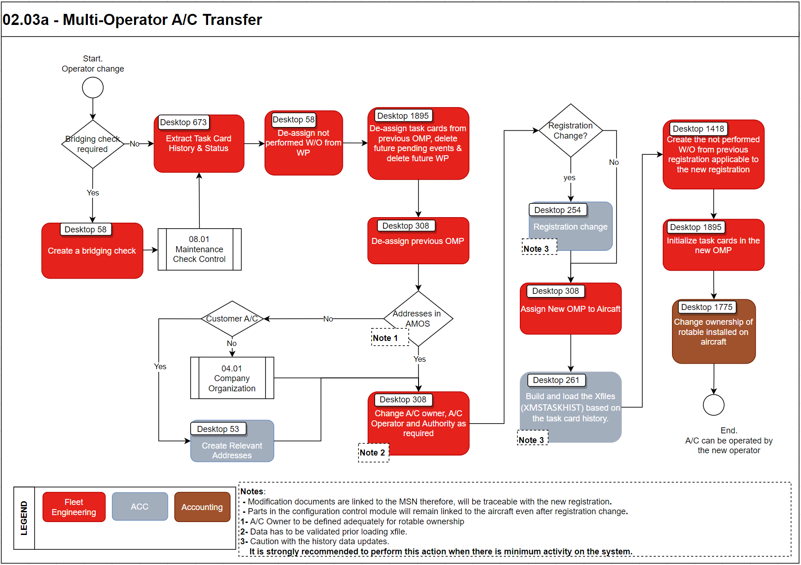
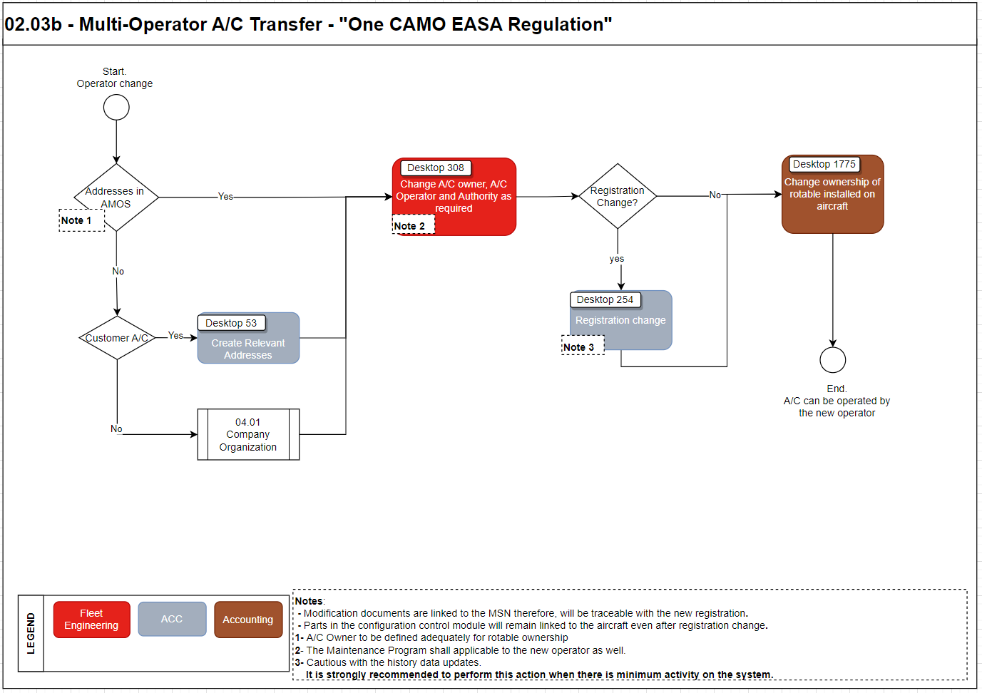

Process Design Questions
# | Question | Answer
1 | Are you using the “one CAMO” Possibility offered by EASA Regulation M.A.201 (ea)?
2 | Is this a regular action? Do you have a team dedicated to this A/C transfer?

Data Source Mapping
Data Sources | Description | Volume / Manual / Automatic / Static / Dynamic
-/- | -/- | -/-

Other Software Used
Other Software | Used by: | Description
-/- | -/-

AMOS Configuration

Process specific configuration programmes
AMOS APN | Notes
-/- | -/-

Basic Data
Basic Data Table | Notes
-/- | -/-

Parameters
Parameter Code | Parameter Name | Notes
-/-

Workflows
Workflow Number | Workflow Name | Workflow Setup Notes
-/-

Scheduled Tasks
Scheduled Task Reference | Frequency | Notes
ExtractTaskcardDueValues | -/- | This extract file can be loaded as XMSTASKHIST, after some adjustments to the content of the file.
-/- | -/- | -/-

API’s & Interfaces
Reference | Direction | Trigger | Frequency
-/-

UAT Guidance
A: process none One CAMO
B: One CAMO Process.
Test case number | Test case description | Required data | Required resources
1 (a) | Extract next due dates and download txt file |  | ACC
2 (a) | De-assign task cards, MP and delete future pending events |  | Engineering
3 (a & b) | Change aircraft owner/operator | Addresses of new owner/operator | Engineering
4 (a) | Assign the new adequate Maintenance Program to the aircraft |  | Engineering
5 (a) | Load the XMSTASKPRESET file | Next due date txt file | ACC
6 (a) | Initialize the tasks card from the Maintenance Program | Applicable Maintenance Program ready | Engineering
7 (a & b) | Perform the registration change as required | New registration available | ACC
8 (a & b) | Perform the change of ownership for parts installed on the aircraft. | Addresses of new owner | Accounting
-/- | -/-

Annex – Additional Info
-/-

